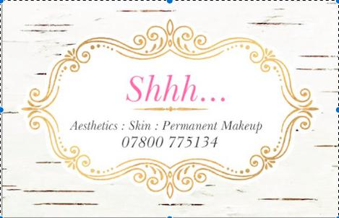

Facial Aftercare

Please read the advice below

Please take a moment to read the aftercare advice below; Your skin and the underlying structures have been stimulated during your facial, and it is important not to stimulate the skin further as this could cause redness and/or irritation.
Over the next 24 hours:
- Avoid wearing make-up.
- Cleanse and moisturise your face to prevent moisture loss
- Avoid direct and indirect heat, such as a saunas, hot baths, showers or a hot hairdryer.
- Sunbathing or prolonged sun exposure.
Over the next 48 hours:
- Do not apply perfume or perfumed products to the treated area.
- Do not undertake any other facial skincare treatments within 48 hours.
Over the next 72 hours:
- Do not apply any other exfoliating skincare products for 72 hours after facial.

General advice:
- Protect your skin in harsh climates, such as the cold in winter and hot sun in summer. Use products that contain SPF.
- Cleanse, tone and moisturise your face regularly to keep it free from blemishes and bacterial build ups to keep your skin soft and supple.
- Never go to sleep wearing make-up; remove all traces of make-up at the end of the day.
- Drink plenty of water (Recommended 6-8 glasses per day).
- Eat a healthy, balanced diet; Include at least 5 portions of fruit and vegetables each day.
- Avoid smoking.
- Avoid drinking large amounts of alcohol.
- Use the correct skin products for your skin type.
- For long term results book in for a regular monthly facial treatment.
If redness or irritation occurs, apply a cold compress or cooling spray to the area. Seek GP assistance if the symptoms do not improve within 24hrs.

Ready for your next appointment?
Why not make it a regular thing? Regular facials are known to be beneficial to your skin’s health. If you enjoyed your session with us, you can secure a monthly slot and we’ll keep you looking your best, month in – month out.

/sunbeds and heat e.g. saunas for 48 hours after having a facial.

