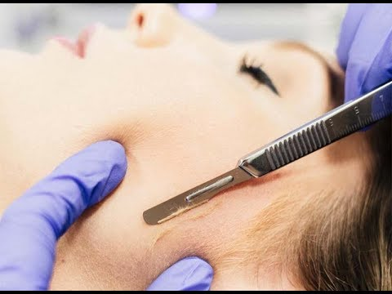

Dermaplaning: Fast facts

- Dermaplaning is a cosmetic procedure that removes the top layers of your skin. The procedure aims to remove fine wrinkles and deep acne scarring, as well as make the skin’s surface look smooth.
- Dermaplaning is safe for most people, with little risk of side effects when a qualified therapist performs it.
- This procedure doesn’t require any downtime for recovery, which makes it extremely convenient.
- Dermatologists say this treatment is effective for people looking to make their skin appear more youthful, smooth, and bright, but results typically only last three weeks.

What’s Dermaplaning?

Dermaplaning is a skin treatment that uses an exfoliating blade to skim dead skin cells and hair from your face. It’s also called skin blading.
Dermaplaning aims to make your skin’s surface smooth, youthful, and radiant. This treatment claims to remove deep scarring from acne and uneven pockmarks on your skin. It’s also used to remove “peach fuzz,” the short, soft hairs on your face.

Dermaplaning can be used for any skin type and anyone with:
- Acne scars
- Dull skin
- Dry skin
- Sun-damaged skin
- Fine wrinkles

There’s little to no downtime required after a Dermaplaning treatment. You won’t need to take time off from work, and you may even be able to fit it in during your lunch break.

How it works

If you look at the tool used for Dermaplaning treatments, you may notice it is a surgical scalpel same as used in surgeries by surgeons.
By aiming a sterile blade at a 45-degree angle and dragging it slowly across your skin, you remove dead cells, scar tissue, and other debris that may be making your skin’s surface look uneven.

Your skin is exposed daily to harsh environmental toxins, irritants, and sun damage. This can cause the top layer of your skin to appear dull, and it can make you look aged.

Dermaplaning clears away those damaged skin cells so newer skin cells are what you see when you look in the mirror.

The procedure

During a Dermaplaning procedure, you shouldn’t feel any pain. You may feel a tingling sensation during the treatment.

First, you’ll lie down on your therapist’s chair in a clean, comfortable room.
After you’re relaxed, your therapist will use a manual Dermaplaning tool to scrape over your skin at a 45-degree angle. This will continue for 20 to 30 minutes, on average, as your therapist gently works to exfoliate the skin.
After the treatment is finished, your provider will soothe your skin with a topical soothing balm. They will also apply sunscreen to protect your face.

Risks and side effects

Dermaplaning is a low-risk procedure. Side effects may include slight redness in your face in the hours after getting the treatment.

Some people develop whiteheads on their skin in the day or two after Dermaplaning.

Infection and scarring are rare after Dermaplaning, but they do occur.

If you develop a scar from Dermaplaning, your doctor may need to treat the scar tissue with a steroid injection to soften the scar tissue.

Another possible side effect is a patchy skin pigment in the area where you have the procedure, which may decrease or disappear as time goes on.

What to expect

You don’t need to plan any downtime to recover from a Dermaplaning treatment. You may experience redness or feel like your skin is scraped in the two or three days right after the procedure.
You may notice that your skin looks brighter immediately after you’re finished with a Dermaplaning treatment, but it often takes a few days to appreciate the full results. As any redness subsides, you’ll be able to see the results more clearly in the days afterward.

Results of Dermaplaning aren’t permanent. The procedure claims to clear away up to three weeks’ worth of dead skin cells. After three weeks to a month, your results will have faded.

After a Dermaplaning treatment, you’ll need to be extra careful about sun exposure. Sun damage could reverse the effects of Dermaplaning, or create pigment blotches on your freshly uncovered skin cells. In the weeks after a Dermaplaning treatment, don’t leave the house without wearing sunscreen on your face.

Preparing for Dermaplaning

Before you have a Dermaplaning treatment, you’ll need to have a conversation with your therapist. Your medical history, skin type, and skin coloring will be discussed, as well as the results you want and if you are a good candidate for this treatment.

If you have an active acne flare-up, you may need to reschedule your appointment to avoid irritating your skin further or tearing your skin’s surface.

You’ll also need to avoid direct sun exposure in the week prior to your appointment, as sun damage, such as sunburn, could compromise your skin and make the treatment painful.

Aftercare

You must not use any products with Retin A, Retinol or any BHA or AHA topical peel products in for the first week. Use a very gentle moisturizer checking carefully for the above ingredients. You can wash your face in warm water gently patting dry before applying moisturiser. Do not use a topical mechanical or face wash exfoliator for the 1st week.

